Juniata College
Language in Motion
1700 Moore St.
Huntingdon, PA 16652
Tel.: 814-641-3493; Fax: 814-641-3155
roneyd@juniata.edu
www.language-in-motion.net

Request for use of name:

If you would like to be a participating institution in the Language in Motion consortium, we ask that you demonstrate that by connecting yourself officially with our program.

Although each of the participating institutions are welcome to name their version of Language in Motion whatever they choose to name it, from purely a collaborative grants perspective it actually behooves all of the partners in the Language in Motion program to demonstrate a common thread and shared purpose. The easiest and most apparent way to demonstrate that connection is to share the same name, such as Language in Motion – [name of institution] or [name of institution] Language in Motion. If the partner chooses to name their version of the program something entirely different, a “small print” claim at the bottom of their letterhead noting that they are “A Language in Motion participating institution” would also demonstrate the connection (albeit less powerfully).

There are two side benefits to using the Language in Motion name: It establishes “prior use” of the name in each of the states wherein a partner institution resides and effectively inhibits others from using it in those states, and it establishes a brand and brand name that we can carry forward to even more partners and present to potential funders in the future.

If you would like to affiliate with our program, just send a written request (by mail or email to the appropriate address above) with the name you wish to use and we will gladly send you permission.

Sincerely yours,
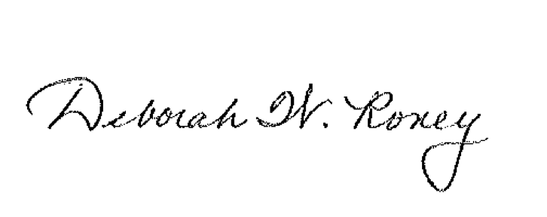
Deborah W. Roney Michael S. Keating
Director, Language in Motion Director, Corporation and Foundation Support

