Juniata College Raystown Field Station
Maple Syruping Manual
by C. Griffin, D. Grove, B. Olsen, and C. Yohn
1993, 1999 (revised)

I. INTRODUCTION
Maple Syrup is one of the oldest known agricultural products and one of the very few that is produced solely in North America. Although the origin of Maple Syrup remains veiled in the early history of this land, it is known that Maple Syrup was a well established item of barter among Native American tribes in the Great Lakes and St. Lawrence region well before European settlers arrived. Three hundred years have passed since then and the people and landscape of this region have changed dramatically, but the fundamental process of Maple Syruping remains unchanged. Perhaps it is reliving the syruping tradition of the early pioneers, and those people that came before them, that is a part of the allure of sugaring. Most folks will agree that making syrup is at least as enjoyable as having Maple Syrup at the breakfast table.
In theory, maple syrup is rather simple to make. The nutritive water from maple trees is collected and boiled down to concentrate the sugar. There are no other ingredients added and the product is 100% pure, natural maple extract. One could conceivably make syrup from any species of tree but the Sugar Maple has the highest concentration of sugar to begin with, (3%), as well as a pleasing flavor. Thus, syrup production in North America is normally restricted to Sugar Maples.
II. EXTRACTING THE SUGAR WATER
WHAT TO TAP
Maple trees can be difficult to identify in the Winter. In the summer, sugar maple leaves have a distinctive U shaped sinus in the leaf whereas Red Maples have a V shaped sinus (See figure 1). As the leaves are off of the trees in winter, this characteristic is of little value to the syrup maker. Fortunately, the buds of sugar maples are easily distinguished from red maple buds. Sugar Maple buds are brown and have sharp points whereas Red Maples have blunt, red buds. (See figure 2). The best way to tell Sugar Maples from Red Maples is to look at the tops of the trees where the branches are youngest. The buds are obvious and abundant on Red Maples whereas buds on Sugar Maples are only subtly apparent.
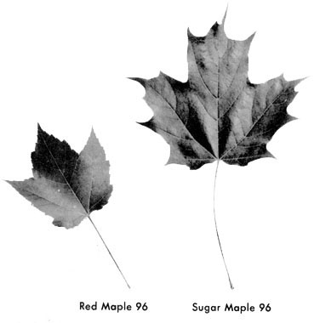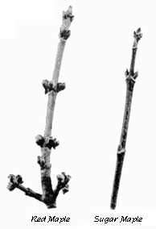
figure 1 | figure 2
It has been suggested that one can easily distinguish maple trees by the bark. Sugar Maple bark is gray on older trees and the trunks are ridged or have long, thick curled plates. Red maples tend to get darker as they age and have long scaly ridges. There is, however, a lot of variation among the bark pattern of maples, and identification of the maple species by the bark can be difficult without a great deal of experience. Always rely on the buds to make the proper identification.
In the past, some students have accidentally tapped oak trees. The buds on the twigs of these trees are alternately located along the stem whereas maple buds are located opposite of each other (Figure 3). Often there are no low branches on the tree to inspect and you may find it helpful to carry a pair of binoculars along when tapping to get a closer look at the buds.
Another way that students have used to identify Sugar Maples is by the presence of previous tap holes. Both oaks and Red Maples have been accidentally tapped in the past and relying on the presence of previous tap holes has propagated that error. Finally, do not tap red maples even if they are convenient. The average sugar concentration in a Red Maple is only 1.5% and thus Red Maple water dilutes the product which only creates additional work.
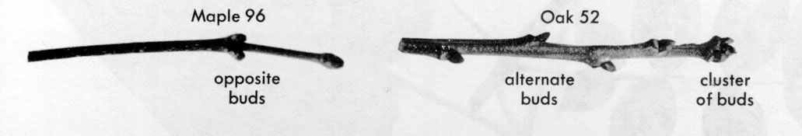
figure 3

SUGAR WATER
Sugar water starts out as glucose that is produced by photosynthesis in the maple leaves. This glucose is drawn down the tree and stored in the form of starch in the roots during the growing season. This energy reserve is then used for growth and reproduction the following year. In the spring, as the weather gets warmer, the sugar becomes mobilized from the roots and is drawn up the tree to swell the buds and feed the branches. On average, only 10% of the sugar water is drawn off of the tree for syrup during a season. When done correctly, this is a sustainable practice. Many sugar camps have trees that have been tapped for 150 years and are still going strong.
Jim Grove, former owner of the house and land making up the current Raystown Field Station, use to say that if they had a good summer, they could look forward to a good sugaring season. A good summer meant more leaves would grow on the trees, therefore, more sugar water would be stored in the wood. Good sugaring weather means warm days (sugar water comes up) and cold nights (sugar water goes down). This keeps the sugar water flowing up and down so it will flow out when the tree is tapped. When the weather stays warm or cold, the sugar water stops flowing.
WHEN TO TAP
The proper time to tap the sugar camp is determined by the weather. A string of warm days (above freezing) interspersed with nights below freezing seems to be the primary cue for the trees to start the sugar water running. This kind of weather traditionally occurs during late February and early March. Nature, however, is often indifferent to our traditions and tapping weather can occur anytime from December to late March. Ideally, we like to have a cold winter so that the sugar water does not flow at all. The advantage of the cold winter is that none of the starch is mobilized early (before we are tapping) and thus we intercept the sweetest sugar water. As a tree continues to mobilize starch, the sugar concentration diminishes. Some syrup producers like to tap as early as possible in the season in order to produce as much syrup as possible. This approach, however, has a few problems. First, it creates a much longer sugaring season for only a little more syrup. This is a lot more work than we are interested in. Second, If we can't empty our buckets due to deep snow, ice can expand the buckets to the point that they rupture and we are left with no syrup to show for the whole effort.
The Raystown Sugarbush has about 200 taps that are on plastic tubing. Rather than having to collect buckets, plastic hoses are connected to each tap and the water is gravity fed down to a central collection point. This approach has several advantages including the fact that freezing is not an issue. There are disadvantages, however, including the difficulty of cleaning the tubing and the problem of line breakage. If we rupture a bucket, we lose, at the most, a quart of syrup. However, if the line breaks due to a fallen branch or wildlife activity, we lose all of the taps on that line. That may amount to several gallons of syrup.
We generally wait until the middle of February to tap. Most of the cold weather season is over and yet it is early enough to avoid emerging insects which tend to get into the collecting buckets. Insects that we commonly encounter include moths, spiders and ants.
Back when Dean Grove went to school, his neighbor, Mr. Hess, tapped in January. He used wooden spiles made of sumac. For buckets, he'd use anything he had, even crocks and lard buckets. Many of his buckets held ten quarts, about what a scrub bucket holds. Mr. Hess boiled the sugar water down in kettles. When an auctioneer would sell off several farms at a public sale, Mr. Hess made candy and sold it for five cents a cake or six pieces for twenty-five cents. When the Groves were thinking of starting to tap their trees, he would quit. Mr. Hess did very well.
As the sugaring season progresses, both the days and nights will become warmer. When the nights get above freezing, the trees begin sap production and the sugar water turns milky and bitter. This is the signal that the sugaring season has ended.
HOW TO TAP
After we have decided when to tap, be it January, February, or March, the next thing to know is how to tap. Tapping is the most difficult and critical part of the sugaring operation and in many sugar camps, the tapper is the most respected of the workers. Typically, a person will require several years of experience before he or she is entrusted with tapping the sugar grove.
DETERMINING WHERE ON THE TREE TO TAP
The best place to locate a tap is between a large root and a low healthy branch. This technique intercepts the greatest water flow. There is a fundamental problem with this approach however. Whenever we tap a tree, we kill a small, diamond-shaped portion of the cambium approximately 12 inches in height and 5 inches in width (Figure 4). In the short run, the portion killed is insignificant as the tree will increase in diameter as it grows and lay down new cambium over the old dead streak. Where we can run into trouble, however is if we put in too many taps or don't place the taps carefully, we can create an extensive dead streak and permanently damage a significant portion of the tree. The rule of placing the tap between a good branch and root is only appropriate for the first few years that the tree is tapped. After that, we ignore the rule or it will get us into trouble.
Do not bore a hole too close to a previous tap. It is critical to offset the next tap to avoid the 18 vertical inches of dead zone. Always tap at least 6" laterally or 2 ft. above or below a previous tap hole (Figure 4).
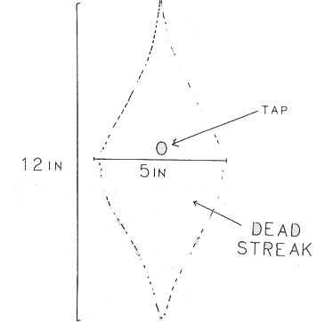
figure 4

NUMBER OF TAPS PER TREE
As trees increase in diameter, they can accommodate more taps. The chart below provides the relationship between tree diameter and the appropriate number of taps.
Tree Size vs. Tap Number
Tree Diameter (dbh) in Inches | Maximum Number of Taps
10 - 16.9 | 1
17 - 23.9 | 2
24 - 29.9 | 3
30 + | 4
*Do not place more than four buckets on a tree.*
It can be difficult to estimate tree diameter when tromping around in the snow and to simplify the process we have made use of an old forestry tool called a Biltmore Stick (Figure 5). To use a Biltmore Stick, merely hold the stick at arms length against the tree in consideration. Close one eye and line up the zero edge of the stick with the left edge of the tree and look to see to measurement on the stick that corresponds to the right edge of the tree. The sticks are marked out in the appropriate number of taps according to the table above.
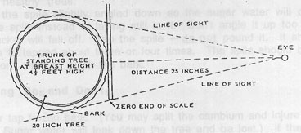
figure 5
Always be flexible when placing taps. The location of the bucket may not be ideal and you may have to locate the tap on the far side of the tree. If the taps are not properly spaced from year to year, a dead streak can be created all the way around the tree and the tree is effectively "girdled" or "ringed". This is usually fatal to the tree and thus the placement of the tap hole requires a careful examination of the tree prior to drilling. The most effective placement of tap holes (in the long run) is to spiral around the tree, (either up or down), making certain that you provide at least 6" lateral movement.
figure 6 | figure 7
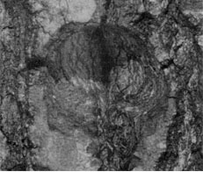 | 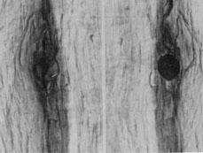
A healing, one-year-old tap wound in a healthy tree. Avoid tapping near these areas to prevent harming the tree by “girdling” it. | A split section of an old tap hole showing the longitudinal stain area above and below the tap hole and the new growth that has covered the outside of the hole (left).
Use a hand drill to bore a hole for the spile. The sugar water flows just inside of the bark, so a deep hole is no advantage. In fact, a deep hole is harder on the tree. Drill in about two inches for small trees and three inches for large trees.
Use of Push Pills:
Paraformaldhyde pills (push pills) inhibit the natural healing process of the tree and thus keep the sugar water flowing under conditions when the tree might otherwise stop production. The benefit is that we get more sugar water. Recently, however, researchers noticed that the tap holes tended to heal more slowly during the summer compared to taps without push pills. Research has also shown the wood infections tend to spread significantly further in trees treated with Paraformaldhyde than in those without Paraformaldhyde. This finding suggest that there is reduced tree vigor from the pills We have stopped using push pills at our sugar bush because of the greater stress on the trees.
Insert the spile slightly angled down so the sugar water will come out of the spile instead of laying still in it. Don't angle it down too much or the bucket will fall off. Tap the spile -- do not pound it. It should only have to tapped about three or four times. The spile should be firm, but we don't want to crack the bark.
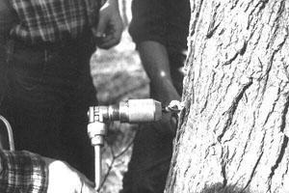 | 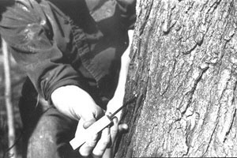
A tap hole being drilled. Vary the height of your holes even if it is more comfortable to drill from the waist.  It’s just a healthier practice for the tree. | A new tap hole being cleaned. Scraping out the shavings helps keep the lines clean and insures  a more steady, even flow.

Tapping Dos and Don'ts
Never tap frozen bark. (You may split the cambium and injure the tree. Sugar water will leak down the tree and be lost.) If there is moisture in the bark, it isn't frozen.
Don't tap low vigor trees. These are trees with several unhealed tap holes. They need a rest. Our trees are overtapped from past seasons.
Don't tap into decay columns. Shavings should be white or cream colored. Dark shavings represent a decay spot and provide little sugar water. Furthermore, the water tends to be off-flavor.
Always use sharp drill bits.
Angle the tap hole slightly downward.
Clean wood shavings out of tap holes. They clog the plastic lines
Always be careful not to overtap when seating the spile. A loose spile can be tightened but an over-tapped spile results in a cracked cambium. All of the sugar water leaks out and the tree is damaged.
Hold your arms steady while drilling or you may produce an oval hole. Spiles may not seat well in such holes.
Hang a metal bucket, with the lid attached, from the spile. Be gentle! You do not want to loosen the spile! Be certain that the spile design matches the bucket design. Some spiles require the addition of a hook (Figure 8).
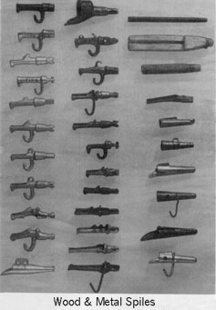
figure 8
Production Per Tap
Individual trees vary greatly in their water supply and sugar concentration. This may be due to the weather, the gene stock of the tree or to local soil conditions. Sugar content even varies during the day and decreases as the season progresses. As a rough estimate, each good tap will produce about 10 gallons of sugar water or one quart of syrup. It is easy then, to estimate the average production of the sugar camp in gallons of syrup, by counting the number of taps and dividing by four. With 400 taps, we should produce 100 gallons of syrup. Unfortunately, we tend to lose a lot of water through leaks, spills, and general inefficiency. A fair amount of syrup is also sacrificed to the waffle gods as well. We are lucky if we turn out 70 gallons of syrup. This inefficiency is something which we all need to work hard to reduce over the next few years (waffle gods excepted).
At the beginning of the season, it takes about 30 to 32 gallons of sugar water to make one gallon of syrup. By the end of the season, it could take up to 45 gallons. Also, the sugar water is sweeter at the beginning of the season compared to a mild taste towards the end of the season.
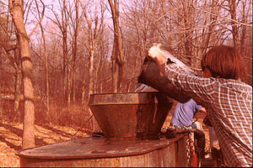
COLLECTING THE WATER

We gather the sugar water by towing an eight barrel (250 gallons) gathering tank through the sugar bush (or sugar grove) with a tractor. We keep the tractor running while collecting the sugar water. This practice uses a little extra gas but this is preferable to having to push start a tractor that is hitched to half a ton of sugar water. We collect the buckets from the trees as we go along and pour the sugar water directly into the collecting tank. It is important to avoid spilling water and to remove and replace the buckets gently. During this operation, it is easy to knock spiles loose which will result in lost sugar water. It is not necessary to remove the lids to the buckets in order to empty them. If it is necessary to replace a lid, set the bucket on the ground first. Do not apply pressure to a hanging bucket or you will loosen the spile. It is often useful to carry a stone along while gathering buckets to tap loosened spiles back into place.
Ice in the Buckets
Ice in the buckets is a mixed blessing. We usually leave the ice in the buckets in order to keep the sugar water fresh and provide weight so that the buckets don't blow off of the trees. However, if very cold weather is forecast and the ice fills over a third of the bucket, it may expand and rupture the buckets. Under these circumstances, dump the ice. Many sugaring operations always dump the ice from buckets as the frozen water concentrates the sugar water. Getting rid of the ice saves us some boiling time However, there is some of the concentrated sugar water in the interstitial spaces of the ice so a lot of sugar water can be lost when dumping ice. Dumping ice thus becomes a judgment call. If there is a lot of ice so that the sugar water can drain out to the bottom and the bucket may be at risk, dump the ice. If there is only a little ice, leave it in the bucket. The wind can really blow strongly down the hollow and the added weight of the ice can be very important in keeping the buckets on the trees.
When the gathering tank is full, it is brought up to the sugar shack and drained into the storage tank. A sheet is placed on the end of the storage tank to act as a filter. Aluminum panels lay on top of the storage tank to keep out rain, snow and foreign objects.
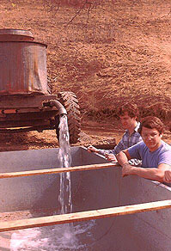
III. FROM SUGAR WATER TO MAPLE SYRUP
After the trees are tapped, the next thing to think about is starting to boil the sugar water. It's very important to take the sugar water in and evaporate it as soon as we can, especially if the weather is getting warm. If it is cold enough that there is ice in the buckets or in the storage tank, the ice will hold the sugar water so that it won't sour. However, if the temperature gets up to 50 degrees and water is left in the buckets or the evaporator, the sugar water will sour and not make good syrup. Through the years, we have found that by taking sugar water in and evaporating before the weather warms up, we'll get better quality syrup-- the proper quality.
Preparing the Pans
Before filling the evaporator pan with sugar water, make certain that the drain is closed. Water should flow from the float pan to the evaporator pan and then to the finishing pan in a single route (Figure 9). The route that the water flows is determined by the placement of the flow pipe out of the float pan and by the placement of the stoppers. Make certain that all stoppers and flow pipes are attached securely. Do not build a fire until you are certain that there is unobstructed water flow throughout the system. Furthermore, do not build a fire until the thermometers are installed!
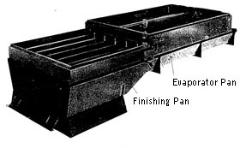
figure 9
Put at least three inches of sugar water in the pans before starting to fire. The fresh sugar water is termed "green" -- referring to the fact that it has not been cooked down at all. We generally use pine slab for fueling the fire as we tend to get a hotter fire. Although hardwoods put out more heat in the long run, pine burns more quickly and is thus a more appropriate fuel for our set-up. It takes a good hour or two before the coals get right and the first run will require several hours in order to establish the concentration gradient in the pans. After that, we can usually draw off syrup every half hour.
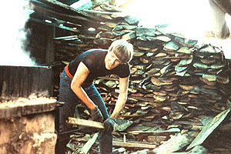
The Fire
The best way to fire is to open only one door at a time. Open one door and put in a few sticks, then open the other door and put in a few sticks. This will prevent cold air from entering and the temperature will stay constant. To get the most out of the evaporator, maintain the fire this way. Don't fill it and go sit down.
At no time, should the firewood be touching the pan. When the wood gets hot, it puts too much heat against the pans causing them to warp. There should be four to six inches of air space between the fire and the finishing pan.
If the fire is good and the operation is run correctly, the evaporator will make three gallons per hour or more. If the heat of the fire is inconsistent, we'll only produce about two gallons per hour. Maintaining a hot consistent fire is an art and requires the constant attention of the syrup maker. Some syrup producers have avoided this task by firing with oil instead of wood. This approach tends to get better evaporation because of the improved consistency of the heat. We could probably make one to one and a half more gallons per hour with an oil fired system but our resident pyromaniacs would be heartbroken.
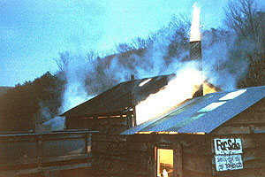
THE THERMOMETER
The critical factor for determining when the sugar water is sufficiently concentrated to qualify as syrup is the density. We can measure the density with a hydrometer but the process is awkward. An easier method is to monitor the temperature of the syrup. At exactly 71/2 degrees above the boiling point of water, the sugar water is of sufficient density to qualify as Maple Syrup.
At the outset, it seems that you could just draw off all of your syrup at 219.5 degrees and be done with it. Unfortunately, it is not that simple. The boiling point of water varies slightly with the atmospheric pressure. Daily changes in the weather change the boiling point and thus the temperature at which we draw the syrup off. This may seem like a trivial point but the effect on the quality of the syrup is dramatic. Draw the syrup off too soon and the syrup is watery and tends not to store as well. Draw the syrup off the syrup too late and the syrup is dark with a stronger, less pleasing flavor. We aim for perfection.
The simple way to remedy the situation is to monitor the boiling point of water during the course of the run. We keep an extra thermometer to check the boiling temperature where the dilute sugar water enters the evaporator pan and this provides us with a running reference point. So when someone takes over the finishing pan work, the first question they should ask is what temperature are we drawing off at and then they should verify it for themselves.
A word of warning: The temperature dial on the thermometer can be deceiving. First, read the temperature graduations
carefully. Second, the temperature of the syrup tends to remain stable approximately 4 degrees below the drawing point for quite a while. It will then increase rapidly (within a minute or so) up to the drawing point. Don't leave the thermometer unattended for more than a minute or so or you may burn the finishing pan as well as the batch of syrup. With experience, you will develop an intuition about the temperature (based on the appearance of the syrup) and thus know when to watch carefully and when less attention is appropriate. Until you develop that intuition, watch the thermometer carefully!
THE REFRACTOMETER
As a quality control measure, we have begun using a refractometer to measure the syrup density. The refractometer is the most reliable method to test syrup quality and it is simple to use. It is based on the concept that liquids refract (bend) light and the greater the density of the liquid, the greater the refraction. The density of liquid sugars is measured in Brix, a unit used commonly in food industry. To use a refractometer, we merely apply a thin layer of syrup to a small glass window in the device. The light passing through the window is bent by the sugar crystals and strikes a printed Brix scale in the refractometer. Clear water on the window gives a reading of 0 Brix. Maple syrup bends the light dramatically striking much higher on the scale. Syrup is at the correct density between 67 and 69 Brix.
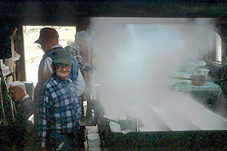
HOW TO EVAPORATE:
We carry no less than three inches and no more than six inches of sugar water in the pans. This level is set by the float control at the evaporator pan intake pipe. When firing syrup, continually check to see that the float valve is functioning and that there is sufficient water in the holding tank. If water stops coming in, whether due to a system blockage or because of an empty tank, we could burn up the finishing pan. This is a several thousand dollar mistake. Always carry at least an inch of water in the pans and monitor the holding tank volume.
The finishing pan is divided into a series of four connected channels. The last channel of the finishing pan is kept blocked off from the rest of the water flow and in that channel, the syrup is produced in batches. If this channel is not kept blocked off, dilute water will continue to flow into it until both of the pans are full of syrup. This would be a real mess. Thus, we use the last channel as the final syrup section and draw that channel off in batches. When the syrup has been drawn off, we quickly refill the channel with the most concentrated sugar water from the next channel over. This is done quite simply by removing the stopper and letting the adjacent channel flow into the finishing channel. As the sugar water in the finishing channel condenses, we add additional sugar water with use of a scoop. When scooping water, always scoop in the direction of the water flow and not against it. In this manner, there is less disruption to the concentration gradient and the syrup cooks faster.
Draw syrup off when the thermometer indicates the appropriate temperature. Draw off the entire channel even though the temperature will drop. If the stopper is tight and the channel is mixed correctly, the entire channel should be syrup. The temperature drop reflects the fact that the thermometer is exposed to cool air as the fluid level drops in the channel.
When drawing, let the syrup run into the bucket. Don't worry about getting a full bucket, worry about burning the pan as the water level drops!. We are only concerned about the syrup quality, not the quantity and the syrup drawing is a particularly critical time.
Do not open the plug to the adjacent channel while taking off the syrup. If the plug removed, water going into the finishing channel may run into the draw valve, diluting the syrup.
Draw the syrup off of the finishing channel until just less than one inch of syrup remains. Then shut the draw valve and open the stopper to the adjacent channel. It is important to avoid drawing the finishing channel down to the point where the syrup can scorch on the bottom. It is a mistake that one can taste for several subsequent draws.
If the syrup starts to boil over the pan, add a few drops of cooking oil to disperse the foam.
Use a straining scoop to continuously skim the pans for foam and debris that has escaped the filters. When skimming the finishing pan, always move the skimmer slowly, moving in the direction of the concentration gradient (direction of the water flow). Avoid disrupting the concentration gradient as much as possible. Debris skimmed from the pans should be deposited in a bucket rather than on the floor.
Burned Syrup
It has happened before and it will probably happen again. In case of a burned batch, here are some guide-lines.
1. If the syrup is merely over-cooked and dark, jug it separately and mark it as burned. It makes good candy. Monitor the flavor of the next few batches carefully. If they taste burned as well, you will need to shut down the operation and clean the pan. Seal off the evaporator pan with a stopper and drain the finishing pan after it has cooled down. Throw the water away.
2. If the surface of the finishing pan was exposed and there are signs of niter or carbon, shut down the operation and clean the pan. Seal off the evaporator pan with a stopper and drain the finishing pan after it has cooled down. Throw the water away.
3. If the water is seriously low in the finishing pan and systemic burning is obvious, immediately dump a bucket of cold water into the pan to keep it from warping from the heat. Don't worry about the loss of syrup, save the pan. As in the cases above, you will have to shut down to thoroughly clean the pan. Check for blockages in the pan joints, float system and feed lines. Determine why the water went low before starting back up.
There are two scenarios when burning has occurred in the past. The first is when a single person is trying to run the whole operation alone and can't keep up. This is not appropriate for a variety of reasons. One person can not competently pay attention to all aspects of the operation and our sugar camp exists for learning and recreation, not syrup production.
The second scenario occurs when a competent syruper leaves an untrained person in charge. The remedy is simple. Always teach the others in the sugar shed how to do your job and let them get practice. Making the Maple Syrup is not as important as teaching people how to make syrup.
FILTERING THE SYRUP
The syrup in the bucket should be poured into the filter while it's hot. Wool filters are used to remove the lime and sediment from the syrup. Sometimes muslin filters are put inside the wool filters. If we did not use the filters, we would have a quarter to a half-inch of sediment in the bottom of the jugs.
After taking off two to three buckets of syrup, change and clean the filter. Rinse the filter thoroughly in hot tap water, but do not use soap. Then place the filter in the boiling water of the evaporator pan. This procedure not only sterilizes the filter, but it also significantly reduces the dilution that would occur the first time that syrup is poured through the soggy filter. (Syrup contacts sugar water rather than tap water). As the season continues, the amount of sediment and lime increases, causing the filters to need washing after every bucket of syrup. When the season is done, wash and dry the filters so they're good for the next season.
CHECK THE SYRUP QUALITY
If you wouldn't use a batch of syrup as a prime example of Maple Syrup, don't jug it! Never send off-flavor syrup to someone's breakfast table. Throw the syrup out. Don't be disappointed because if it doesn't taste perfect, it isn't Maple Syrup. Sources of off-flavor include:
Buddy or Bitter | This is common in the later part of the season and it means that you should shut down and dump the remaining water. The sap is sour.
Burnt | This occurs when niter builds up at the draw spots. Stop the operation and clean the pans.
Detergents or Perfume | Someone washed the filters with soap (a serious error)
Moldy | Occurs when the wool filter has sat in the moist darkness too long. Replace the filter.
Rancid: | Occurs when folks use rancid defoamer (oil). Always use fresh defoamer and use it in moderation.
JUGGING THE SYRUP
Always use hot fill syrup. Always leave an inch of air space at the top of the jug. Carefully wipe off any spilled syrup on the jug lip as well as on the outside. Syrup on the lip may create an entry point for mold or bacteria. Screw the cap down tight and invert the jug. The hot syrup then sterilizes the inside top of the cap.
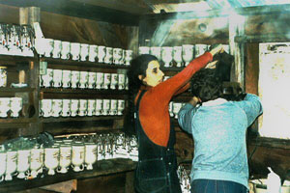
Syrup Grading
The first run of syrup should have the color of wheat straw and have a mild, smooth taste. As the season progresses, the sugar content of the water decreases and a longer boiling period is required to produce the syrup. Later in the season the syrup gets darker and has a stronger maple taste. The syrup produced early in the season is preferred by many and fetches a higher market value. It is often referred to as Grade A, Fancy or Light Amber syrup. This syrup sells in Vermont for up to $60.00 per gallon. Despite the reputation of the Light Amber syrup, many folks prefer the stronger maple flavor and deeper color of the later runs.
For the fun of it, we have begun grading the quality of our syrup. We have a series of grading colors to compare our syrup to giving categories of light, medium and dark amber. To grade syrup, merely place a sample of the draw in the small glass jar provided with the grading kit. In good light, compare the color or the draw to the three standards. Determine the highest standard that is still darker than the draw. The draw is then graded as that standard. Then apply the correct grading stickers to the jugged syrup from that draw.
Mark the run number on the bottom of the jug and record it on the tally sheet to keep track of how much syrup is made. A "run" refers to each time the sugar water flow stops (when we can't collect because of the weather).
CHECKLISTS

Set-up | Clean-up | Administration
Wood supply | Clean storage tanks | Tally syrup production
Jug supply | Clean spiles | Record syrup distribution
Sticker Supply | Remove tubing spiles immediately | Distribute syrup
Tractor condition | Backflush tubing
Check trailer condition | Clean buckets, check for leaks
Check Tubing Lines for breaks, etc. | Clean out sugarshed
Clear Sugar Lanes | Restock wood
Clean Jug Returns | Scrub down pans
Check chain saw condition | Clean out fire box (make necessary repairs)
Check chain saw gas and oil supply | Clean syrup dispenser
Sharpen bits | Clean storage barrels
Check hand drills
Inventory pan equipment and filters
Rinse buckets and pans
Clean syrup dispenser
Check condition of storage barrels

