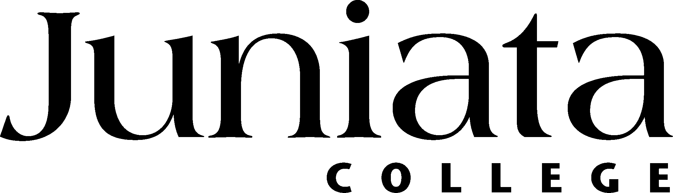

EVALUATION/ASSESSMENT TOOLS

Grants makers fully understand that the outcomes of a college experience are not often recognized until 5-7 years after the student graduates. But at the same time, those grants makers are under enormous and growing pressure to show tangible results from their investments much sooner and often within the funding period of the grant itself (1-3 years). Of course, the grants makers pass that expectation on to we grants seekers by making evaluation and assessment of the program a requirement of the grant (and a grant application)

Some of those grant makers (most notably the National Science Foundation) have invested heavily in developing credible tools that will help to assess program outcomes within short times. Although we may argue about the efficacy of these assessment tools, two facts remain evident:
- Assessment of program outcomes is a growing expectation of grants makers, and
- As grants seekers, we must address that expectation (if we want the money).

Here are several web sites that can help:

The Student Assessment of Learning Gains (SALG) provides survey instruments that can be customized to suit your course offering from one the templates covering diverse disciplines from Physics to American English Conversational Skills.

See SALG at: http://www.wcer.wisc.edu/salgains/instructor/facultyregisteredMenu.asp

The Field-tested Learning Assessment Guide (FLAG) is a more detailed site and provides tools that can help you decide on which assessment tools can be best used to meet your needs. Although primarily for Science, Technology, Engineering, and Mathematics (STEM) disciplines, the FLAG site also offers one of the better primers for assessment tools.

Start your search of FLAG here: http://www.flaguide.org/

Note: As we discover new and broader ranging assessment tools for college/university level programming, we will add to this list.

